

**Salander**

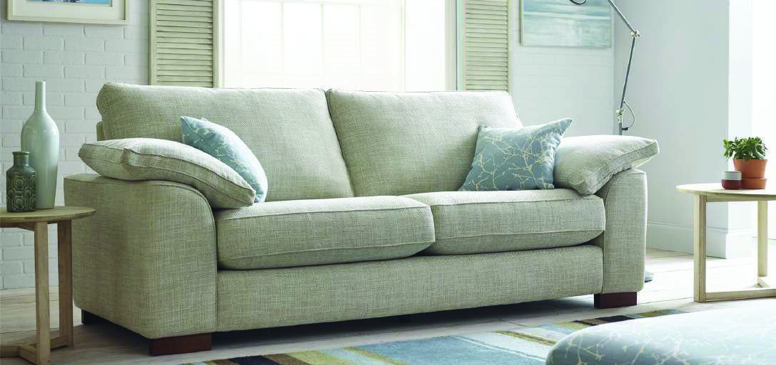

Generously large sofa and chair options, with a contemporary feel and superb comfort. Available in an extensive choice of Aqua Clean and luxury fabrics.

A strong presence matched with extremely inviting comfort…

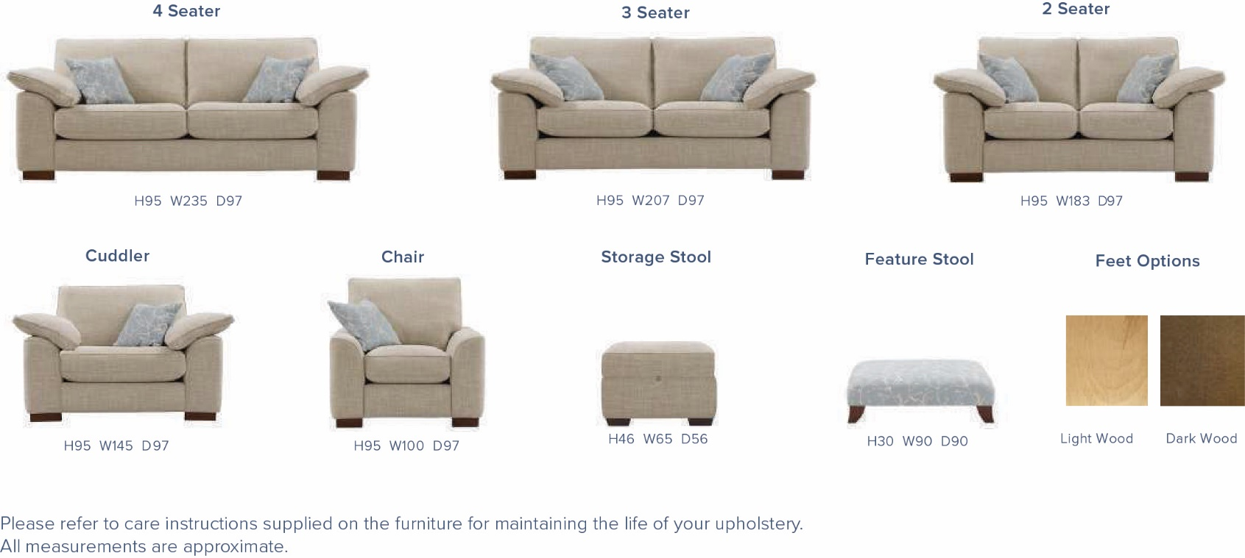

* Chunky wooden feet available in light or dark finish
* Seats sprung by high gauge serpentine springs
* Backs supported by elasticated tensioned webbing
* Hand-crafted and finished to the highest standard
* Reversible soft, fibre filled back cushions
* Frames assembly guaranteed for 15 years
* Duck feather filled arm pads and scatter cushions

The Salander is hand-crafted in the UK from the finest materials sourced from across the world. All components of this furniture have been extensively tested for your peace of mind. Frames are constructed using hardwood, plywood and high-density particle board and are glued and screwed for added stability and strength.