**Furniture Connect**

**Winchester Collection**

**Specification Brochure**

April 2024 Edition

Winchester is a premium oak dining and living range that has been designed to blend effortlessly with any interior design. It oozes quality craftsmanship, solid construction, neat metal handles and a vast choice of items that will carry the theme through from the dining room through to the living room. It boasts a choice of several extending dining tables, to suit any space and family. There are also plenty of options for chairs, TV units, coffee tables, bookcases, consoles and sideboards. Winchester represents the perfect addition to your home, giving you pleasure and convenience for years to come.

**Corner Display Cabinet (HAM-029)**

W69cm x D34.5cm x H190cm

**Wine Rack (HAM-060)**

W55cm x D37.5cm x H182cm

**Display Cabinet (HAM-021)**

W95cm x D37cm x H195cm

**Low Bookcase (HAM-028)**

W85cm x D35cm x H90cm

**Large Bookcase (HAM-001)**

W85cm x D35cm x H184.5cm

**Slim Bookcase (HAM-037)**

W60cm x D30cm x H180cm

**TV Unit (HAM-030)**

W95cm x D44cm x H55cm

**Large TV Unit (HAM-031)**

W115cm x D44cm x H55cm

**TV Unit - Corner (HAM-014)**

W102cm x D51cm x H54.5cm

**Small Hutch (Display Top Only) (HAM-039)**

W105cm x D35cm x H115cm

**Large Hutch (Display Top Only) (HAM-005)**

W151cm x D36cm x H120cm

**Large Sideboard (HAM-003)**

W150cm x D45cm x H90cm

**2 Door Cupboard (HAM-038)**

W80cm x D38cm x H80cm

**Small Sideboard (HAM-002)**

W105cm x D45cm x H85cm

**Console Table (HAM-009)**

W100cm x D45cm x H85cm

**Telephone Table (HAM-018)**

W40cm x D40cm x H76.5cm

**Small Console Table (HAM-009)**

W65cm x D35cm x H80.5cm

**Nest of 3 Tables (HAM-011)**

W65cm x D40cm x H55cm

**Small Coffee Table (HAM-022)**

W90cm x D55cm x H50cm

**End Table (HAM-008)**

W45cm x D45cm x H51cm

**Coffee Table (HAM-007)**

W110cm x D55cm x H44.5cm

**Chair – Padded Seat (HAM-111)**

**(SOLD IN PAIRS)**

W49cm x D54cm x H108cm

**Chair – Wooden Seat (HAM-111-SS)**

**(SOLD IN PAIRS)**

W49cm x D54cm x H108cm

**Slat Back Chair (HAM-112)**

**(SOLD IN PAIRS)**

W44cm x D52cm x H106cm

**Gateleg Table (HAM-245)**

W35cm/93cm/152cm x D65cm x H76cm

**Draw Leaf Table (HAM-164)**

W90cm/160cm x D90cm x H77cm

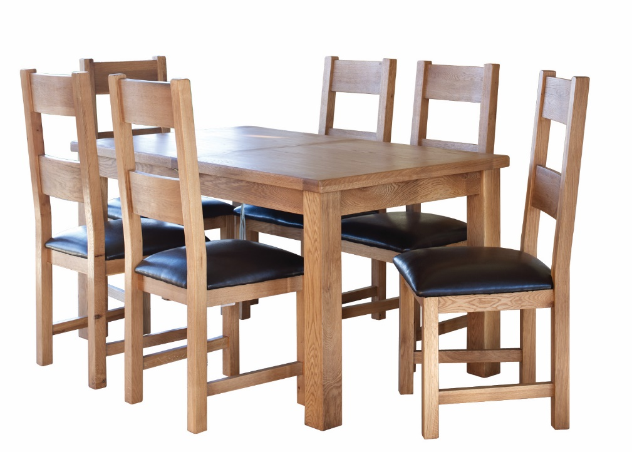

**Extending Table (HAM-203)**

W150cm/195cm x D90cm x H77cm

**Extending Table (HAM-163)**

W120cm/165cm x D80cm x H77cm

**Round Extending Table (HAM-143)**

W107cm/145cm x D107cm x H77cm