

Aston Collection
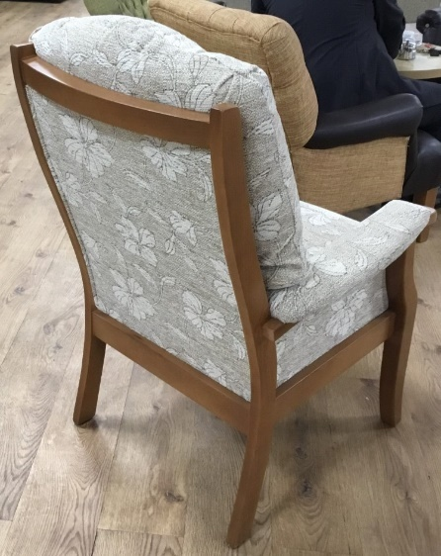
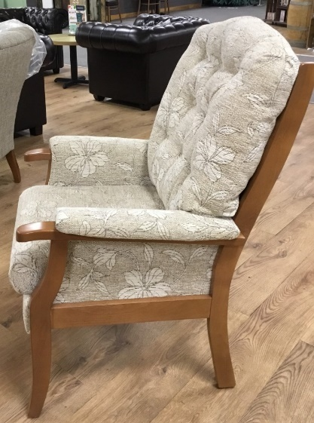
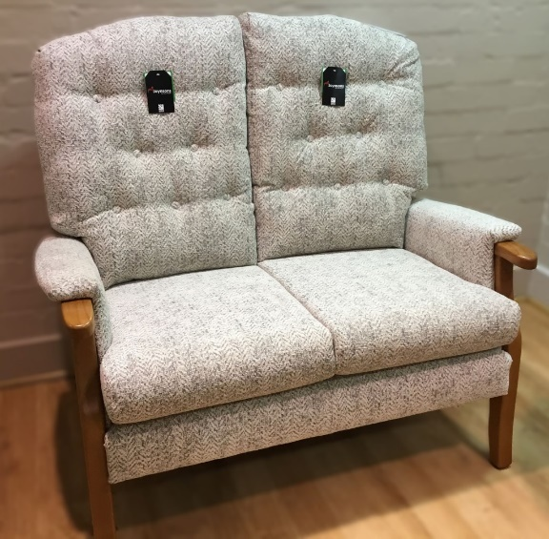

- Elegant design and supreme comfort, with a choice of seat heights
- Available with a matching two or three seater sofa
- Grande Chair and Grande Sofa options (Width and Depth increased)
- Sprung Rocker Chair option available
- Quality Foam seat cushions for supreme comfort and support
- Fibre filled back cushions
- This is a totally British-made product, with all the carefully selected timber coming from sustainably managed forests
- 10-year frame warranty
- Comprehensive choice of hard-wearing fabrics
- Choice of 3 wood colours for the frame
- Footstool options also available

Model | Height (cm) | Width (cm) | Depth (cm) | Seat Height (cm)
Chair | 107 | 67 | 78 | 46
High Seat Chair | 112 | 67 | 78 | 51
Grande Chair | 117 | 71 | 84 | 46
Grande High Seat Chair | 112 | 71 | 84 | 51
Sprung Rocker Chair | 107 | 67 | 78 | 48
2-Seater Sofa | 107 | 113 | 78 | 46
High Seat 2-Seater Sofa | 117 | 113 | 78 | 51
Grande 2-Seater Sofa | 117 | 115 | 84 | 48
Grande High Seat 2-Seater Sofa | 122 | 115 | 84 | 51
3-Seater Sofa | 117 | 161 | 84 | 46
High Seat 3-Seater Sofa | 122 | 161 | 84 | 51

