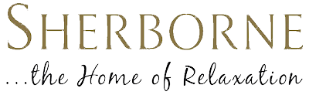

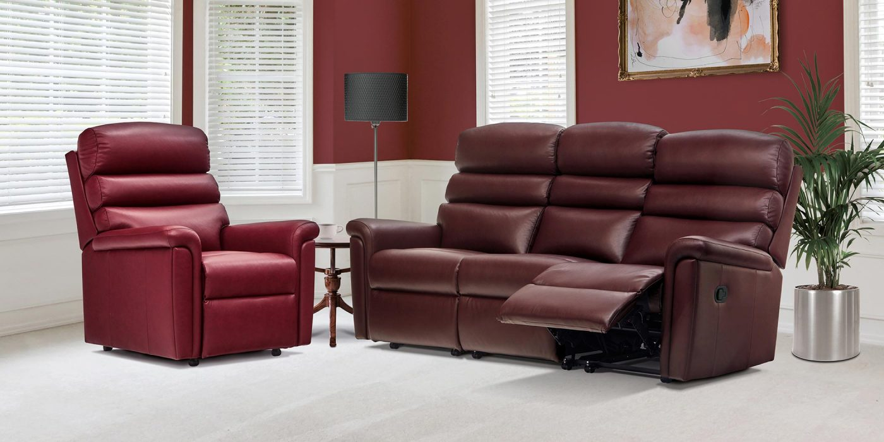Leather Promotion

An Additional 10% Off ALL Sherborne Leather Products

Available until 22nd September, 2025!